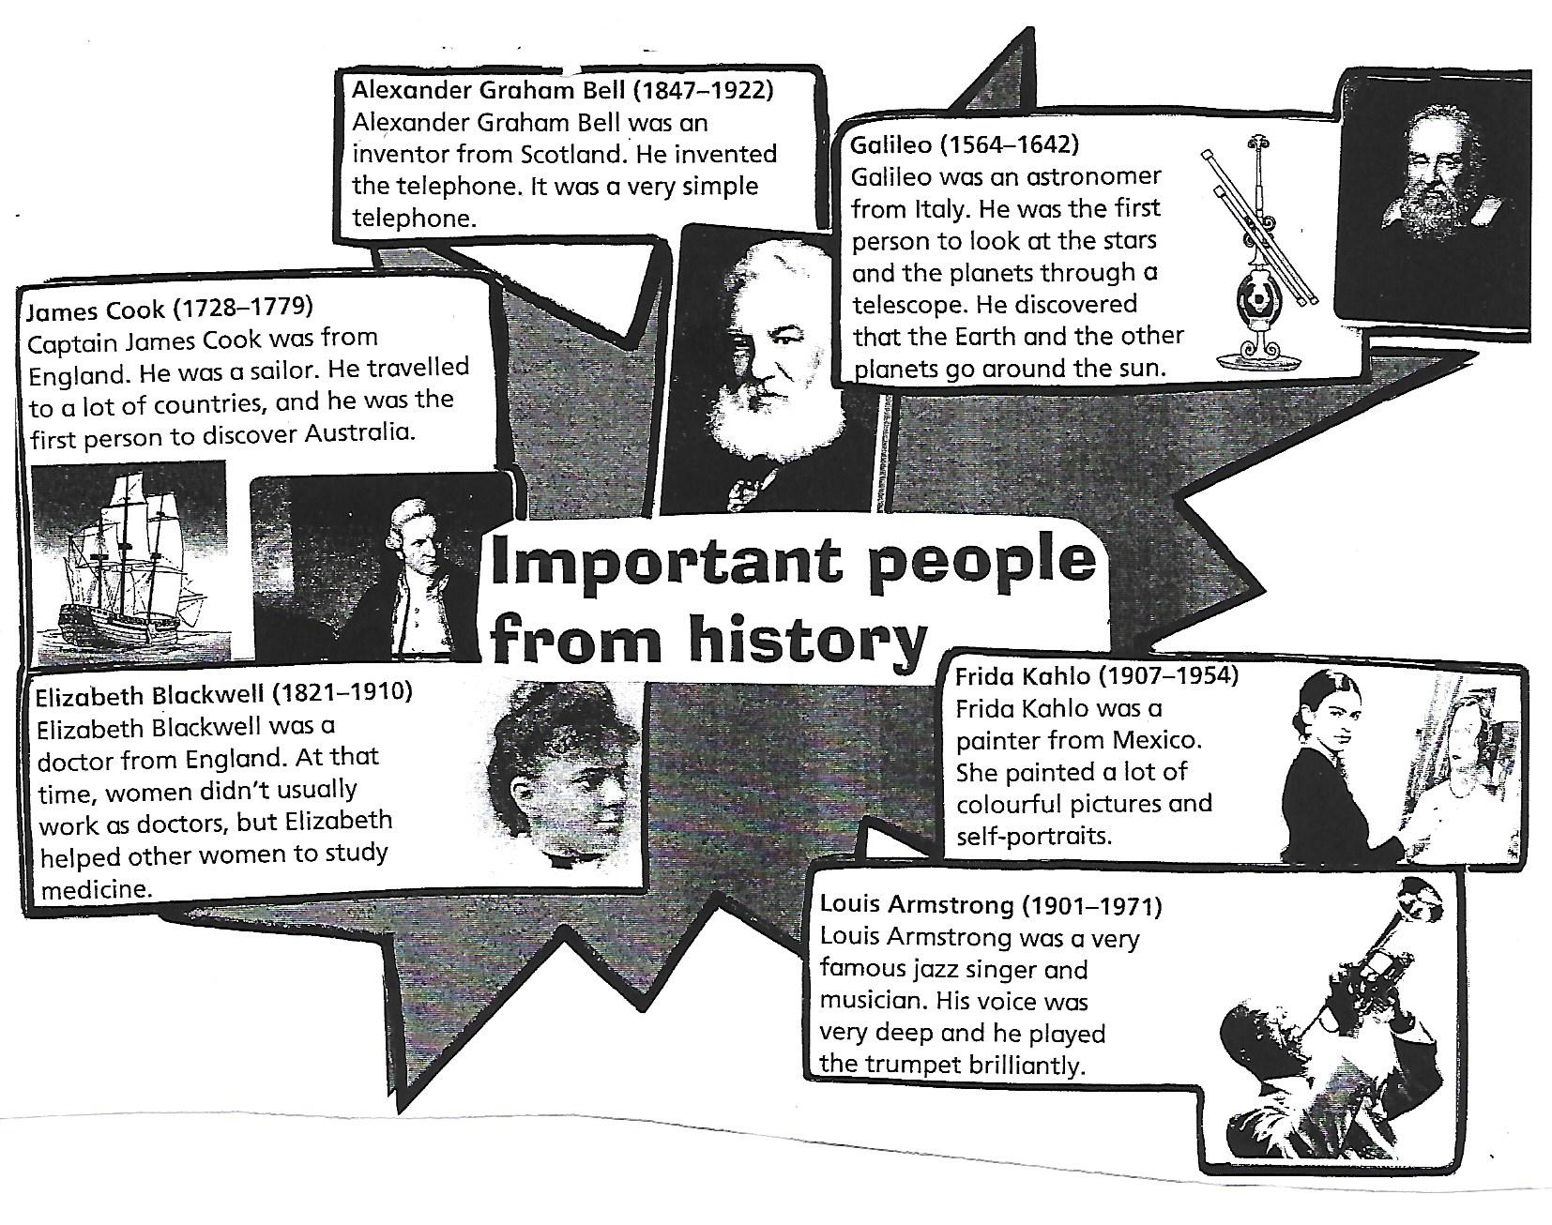
BIOGRAPHIES.
Read and answer the questions.
- Who was Frida Kahlo?

- Was Louis Amstrong a very famous pop singer and musician?

- What did Alexander Graham Bell invent?

- Where was Alexander Graham Bell from?

- Who discovered Australia?

- Who was Galileo? What did he discover?

- What was Elizabeth Blackwell’s job?

